This paper reports on the design, fabrication, and

testing of a 3-axis acceleration switch intended to serve as

an early warning for traumatic brain injury (TBI). Mild

TBI (colloquially termed “concussion”) resulting from

rapid acceleration of the skull has been rising in the public

consciousness with recently increasing awareness of the

dangers and long-term health risks associated with it. The

sensor described here is an array of acceleration switches

designed to cover the range of acceleration associated

with TBI, and to do so with no external power draw until

an acceleration event within this range occurs.

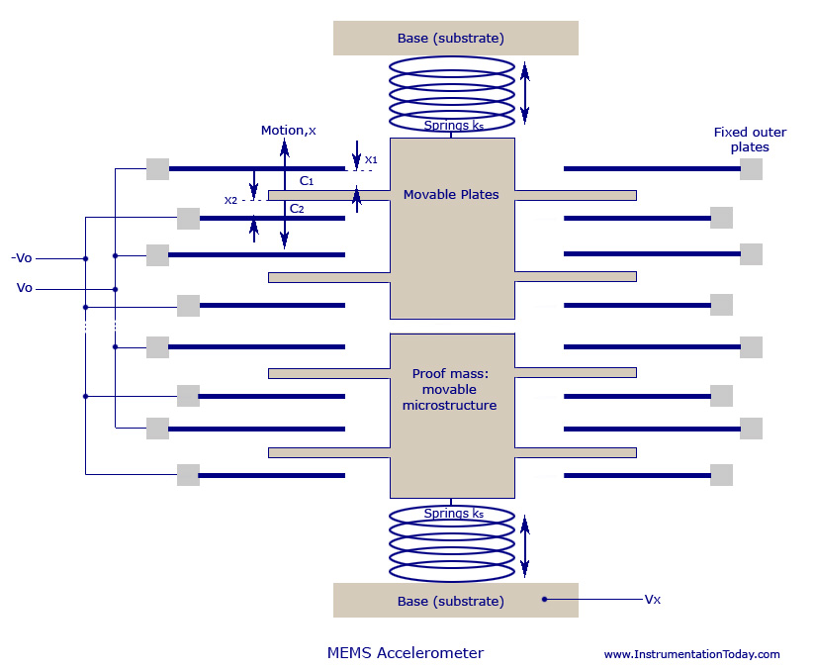

The pinout for all the ADXL ICs is the same as shown above.

ADXL Pinouts

Before we proceed to the Pin Description, we will get acquainted with some basic terms:

1. Input supply voltage: this is the Supply voltage (VSS) for the IC to work on. The ADXL330 and ADXL335 are capable of working on supply voltages ranging from 1.8 volts (minimum) to 3.6 volts (maximum)
2. Ratiometric Output: This means that the output voltage from the pins (ZOUT, YOUT, XOUT) depend on the supply voltage given at the Vss pin.
3. Zero g Bias level: this means the voltage output through the Out pins at the mean position, i.e. when there is no net acceleration in the respective axis.

### ADXL330 vs ADXL335

Now here comes the difference between the two ICs! While in ADXL330, the Zero g bias level for all the Axes stands same at 1.5 volts, typical min at 1.2 volts and typical max at 1.8 volts, in the ADXL335, the Zero g Bias Level is 1.5 volts for all axes as well, but the typical extremes differ: they are 1.35v to 1.65v for the X, Y axes, while they range from 1.2v to 1.8v in the Z-axis.

You might feel there is not much difference between the two. Indeed you are right, but when it comes to precision, ADXL335 is better. Since the typical extremes range is lesser in ADXL335, one will have easier calibration issues and lesser inaccuracies.

**MEMS Devices**

Micro-electro-mechanical Systems (MEMS) Technology is one of the most advanced technologies that have been applied in the making of most of the modern devices like video projectors, bi-analysis chips and also car crash airbag sensors. This concept was first explained by Professor R. Howe in the year 1989.

Today, as the technology has become more advanced the idea of integrating multi-chips is applied on to produce a single chip MEMS with high performance and accuracy.

The main idea behind this technology is to use some of the basic mechanical devices like cantilevers and membranes to have the same qualities of electronic circuits. To obtain such a concept, micro-fabrication process must be carried out. Though an electronic process is carried out, an MEMS device cannot be called as an electronic circuit. MEMS duplicate a mechanical part and have holes, cantilevers, membranes, channels, and so on. But an electronic circuit has a firm and compact structure. To make MEMS from silicon process, the manufacturer must have a deep knowledge in electronics, mechanical and also about the materials used for the process.

**Advantages**

1. MEMS device are very small and can be applicable for many mechanical purposes where large measurements are needed.
2. The small size of the device has also helped in reducing its cost.
3. If two or three different devices are needed to deploy a particular process, all of them can be easily integrated in an MEMS chip with the help of microelectronics. Thus, data reception, filtering, storing, transfer, interfacing, and all other processes can be carried out with a single chip.

**Applications**

1. The device is highly applicable as an [**accelerometer**](http://www.instrumentationtoday.com/accelerometer/2011/08/), and thus can be deployed as airbag sensors or in digital cameras in order to stabilize the image.
2. Can be used as a pressure sensor so as to calculate the pressure difference in blood, manifold pressure (MAP), and also tire pressure.
3. It is commonly used in a gyroscope, DNA chips and also inkjet printer nozzle.
4. Optical MEMS is used for making projectors, optical fiber switch and so on.
5. RFMEMS is used for making antennas, filters, switches, relays, RAM’s microphones, microphones, and so on.

**MEMS Accelerometer**

An accelerometer is an electromechanical device that is used to [**measure acceleration**](http://www.instrumentationtoday.com/acceleration-transducer/2011/08/) and the [**force**](http://www.instrumentationtoday.com/force-transducers/2011/07/) producing it. Even today, one of the most commonly used one is the [**piezoelectric**](http://www.instrumentationtoday.com/piezoelectric-transducer/2011/07/)accelerometer. But, since they are bulky and cannot be used for all operations, a smaller and highly functional device like the MEMS accelerometer was developed. Though the first of its kind was developed 25 years ago, it was not accepted until lately, when there was need for large volume industrial applications. Due to its small size and robust sensing feature, they are further developed to obtain multi-axis sensing.

**Working**

One of the most commonly used MEMS accelerometer is the capacitive type. The capacitive MEMS accelerometer is famous for its high sensitivity and its accuracy at high temperatures. The device does not change values depending on the base materials used and depends only on the capacitive value that occurs due to the change in distance between the plates.

If two plates are kept parallel to each other and are separated by a distance‘d’, and if ‘E’ is the permittivity of the separating material, then capacitance produced can be written as

**C0 = E0.E A/d = EA/d**

**EA= E0EA**

A – Area of the electrodes

A change in the values of E, A or d will help in finding the change in capacitance and thus helps in the working of the MEMS transducer. Accelerometer values mainly depend on the change of values of d or A.

A typical MEMS accelerometer is shown in the figure below. It can also be called a simple one-axis accelerometer. If more sets of capacitors are kept in 90 degrees to each other you can design 2 or 3-axis accelerometer. A simple MEMS transducer mainly consists of a movable microstructure or a proof mass that is connected to a mechanical suspension system and thus on to a reference frame.

The movable plates and the fixed outer plates act as the capacitor plates. When acceleration is applied, the proof mass moves accordingly. This produces a capacitance between the movable and the fixed outer plates.

When acceleration is applied, the distance between the two plates displace as X1 and X2, and they turn out to be a function of the capacitance produced.

From the image above it is clear that all sensors have multiple capacitor sets. All upper capacitors are wired parallel to produce an overall capacitance C1 and the lower ones produce an overall capacitance of C2.

If V**x** is the output voltage of the proof mass, and V**0**is the output voltage produced between the plates, then : **(Vx+V0) C1 + (Vx-V0) C2 = 0**

We can also write: **Vx=V0[(C2-C1)/(C2+C1)] = (x/d) V0**

The figure below shows the circuit that is used to calculate the acceleration, through change in distance between capacitor plates. The output obtained for different values of acceleration is also shown graphically.

[](http://www.instrumentationtoday.com/wp-content/uploads/2011/08/MEMS-Accelerometer.jpg)[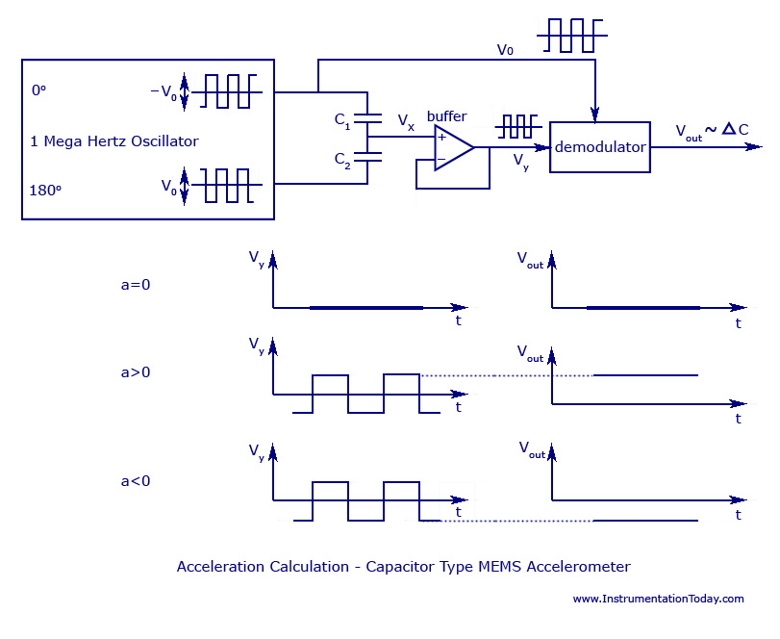](http://www.instrumentationtoday.com/wp-content/uploads/2011/08/Capacitor-Type-MEMS-Accelerometer.jpg)

Capacitor Type MEMS Accelerometer

When no acceleration is given (a=0), the output voltage will also be zero.When acceleration is given, such as (a>0), the value of value of V**x** changes in proportion to the value of V**0**.When a deceleration is given, such as (a<0), the signals V**x** and V**y** become negative. He demodulator produces an output equal to the sign of the acceleration, as it multiplies both the values of V**y** and V**0** to produce V**OUT**, which has the correct acceleration sign and correct amplitude.

The length of the distance, d and the proof mass weigh is surprisingly very small. The proof mass weighs no more than 0.1 microgram and the output capacitance is approximately 20 aF and the plate distance is no more than 1.3 micrometers.